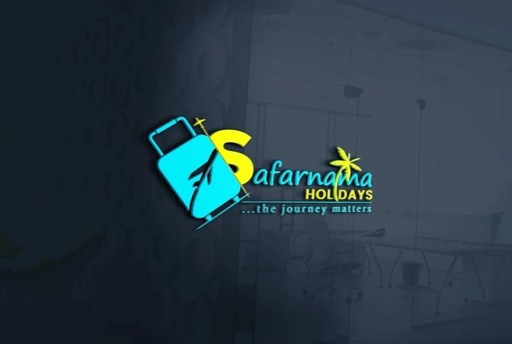
- OFFICE ADDRESS
- SILIGURI :Eastern Bypass, Debi Nagar , Opp. Amar Jyoti International School (HEAD OFFICE)

- GANGTOK: M.G Marg,Gangtok,Sikkim (BRANCH OFFICE)

- GUWAHATI: Satgaon, Narengi Assam(BRANCH OFFICE)

- DARJEELING:Chauk Bazaar,(BRANCH OFFICE)

- JAIGAON :Centre SBI building, (BHUTAN)(BRANCH
OFFICE)

- SHILLONG:Police Bazar, Shillong, Meghalaya(BRANCH OFFICE)

Email:holidays.safarnama@gmail.comwww.safarnamaholidays.co.in
 NO: 8159939566/ 86174 94891/03561-350732

------------------------------------------------------------------------------------------

4Nights 5Days Beautiful Sikkim & Darjeeling
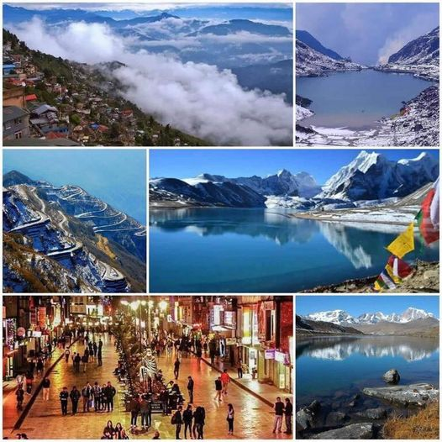
TOURATAGLANCE

DAY 1: NJP/IXB to Gangtok
DAY 2: Visit Tsomgo Lake & Baba mandir
DAY3: Gangtok to Darjeeling
DAY4: Tigerhill & Darjeeling local sightseeing
DAY5: Darjeeling to NJP/IXB drop

02 nights Gangtok & 02 nights Darjeeling

Day 1- (5thJune) Siliguri/NJP/IXB to Gangtok:-
Welcome to the north eastern heaven on earth. Your Sikkim tourstarts here
Meet & Greet on arrival at NJP Railway Station / IXB Airport/ Siliguri & transfer to Gangtok.On arrival Check-in to hotel & rest of the day at leisure.Evening free to go famous MG Road & Enjoy the local Beauty of Gangtok.Overnight stay at Gangtok..

Day 2- (6th June) Excursion to Tsomgo Lake & Baba mandir:-
After breakfast day excursion to the oval shaped Tsomgo Lake (40 kms from Gangtok departure in the morning) - situated at a height of 3,780 mts. with an average depth of 50 ft and home to the Brahminy duck and several migratory birds. On the way stop at Kyongnosla The cool water of the Lake is perfectly attuned with the scenic beauty around. Travel to Baba MandirGangtok another 17 kms beyond Tsongolake. Return to Gangtok. Overnight at Gangtok Hotel. Optional Nathula (Additional Cost) (14140 Ft / 4310 Mts / 20 Kms in 1Hrs one way from Tsomgo Lake) Baba Mandir (13100Ft / 3994 Mts / 16Kms in 1Hrs one way from Tsomgo Lake) is an Indo China border, controlled by the Indian Army & is situated approx 20 Kms ahead of Tsomgo Lake at an height of 14140 Ft / 4310. The journey to Nathula& Baba Mandir is same up to 16 Kms. At this point the right arm of the “V” which is 4 Kms takes one to Baba Mandir& left arm of the “V” which is 4 Kms takes one to Nathula. One can opt for Nathula Excursion by paying a supplement• cost which varies from month to month. Nathula permit gets confirmed 24 hrs prior to the journey date & it is subjected to permit availability as it is allotted as per lottery. Nathula is closed on Monday for tourist. Organizing the permit at the last moment is not possible & a clear window of 72 Hrs with proper documents is required to process the permit. There is no refund, in case the permit is confirmed by Sikkim tourism & due to whatsoever reason (Land slide, Heavy rain fall, VIP Movement, Health issue etc) one is not able to visit.pickup and drop from north sikkim stand for sumo/maxx 8am to 8pm) Nathula extra (Nathula Monday Closed).
(*Nathula pass optional cost extra, it's depends on Army permit & Weather condition. It's directly payable to driver).

Day 3- (7th June)- Gangtok to Darjeeling:-
After breakfast drive to Darjeeling. On arrival Check-in to hotel & rest of the day at leisure. Overnight stay at Darjeeling. Evening free to go famous mall Road Enjoy the Local beauty of Darjeeling.

Day 4- (8th June)- Tiger hill and Darjeeling local sightseeing:-
Early Morning (at 04:00 am) drive to Tiger hill to watch the spectacular sunrise over Mt. Khangchendzongha (28,208 ft. Worlds 3rd highest peak), on your way back visit Ghoom Monastery and Batasia Loop. After breakfast visit Himalayan Mountaineering Institute, P.N. Zoological Park (Thursday closed), Tenzing Rock, Tibetan Refugee self-help Centre (Sunday closed), Tea Garden (outer view), and Japanese Temple.Overnight stay at Darjeeling.
Day 5- (9th June)- Darjeeling to NJP/IXB drop:-
After breakfast at your hotel and proceed for the NJP /IXB. Board your train/flight for your onward destination with cheerful memories of your holiday.

TRANSPORATION | TOTAL PACKAGE COST | Total no of Traveler
01 Private - Wagon-R/Dzire or similar | ₹49,000.00 | 02 Adults & 02 child(9,13yrs)
HOTEL DETAILS | NO OF ROOM | MEAL PLAN
Aurora Gangtok / Narayani Continental or similar or similar @Gangtok | 01 Deluxe room +01 Extra mattress+01 child samebed sharing | Breakfast
Trippo potala palace / Hotel Brodway or similar @Darjeeling | 01 Deluxe room +01 Extra mattress+01 child samebed sharing | Breakfast

PACKAGE INCLUSION

- Meal : Breakfast,
- Vehicle: Non- AC
- Vehicle: Non- Luxury
- Transportation
- Parking
- Permits

PACKAGE EXCLUSION
- Meal : Lunch, Dinner
- Vehicle : Luxury
- Insurance Entrance Fees
- Laundry
- Other Than Mentioned in Inclusion Entry fees Guide charges
- Room Heater
- Others: Other Exclusions(Cost Exclude)
- Any for est safari, elephant safari etc.
- Any expenses of personal nature suchastips, laundry, telephone calls, fax etc.
- Entrance Fees forGardens,ropewayetc.
- Any kind of drinks(Alcoholic,Mineraletc)
- Raftingcharges,Guide)

IMPORTANT INFORMATION

- Theabove mentionedhotelswillbeconfirmedaspertheroomavailability.Otherwisewewillconfirmsimilar categoryhotel.
- Please carry original id proof (identity card - Voter ID card/Pass-port/Driving License etc)forsecurity purpose &hotelpolicy (PANisnotconsidered).

- Booking

Acontractexistsbetweenuswhenwehaveconfirmedyouonourpackagetourofyourchoice and we have received your booking request and deposits. By paying depositconfirms that you and other people on the package accept our booking terms andconditionsandareenteringintothecontract.

- PaymentMode

Deposit All deposits can be made by online transfer (NEFT/RTGS/IMPS/UPI), cash, cheque,Demand Draft. 50% payment have to deposit at the time of confirm the booking andpending 50% payment should be deposited before 7 days of tour starts. The rooms thenwill be blocked, and we will send the confirmation, which completes initial BookingFormalities.

- Balance

Once the booking request and deposit has been received an invoice will be sent, alongwith a receipt for the already paid deposit amount via email. The balance of the paymentmust be paid 7 days prior to the arrival. Any booking made within 7 working days of thearrival is considered to be late booking for which the full and final payment is required atthe same time of booking. Failure to pay the balance within the specified period will resultinthecancellationofthebooking,andinpaymentof acancellationfeeasdetailedbelow.

- CancellationPolicy:(forthelandpackage)

IfTripiscancelledmorethan30daysbeforethestartingdate,25%ofthetotallandPackagecostwillbecancellationfees.
IfTripiscancelledbetween16-30daysbeforethestartingdate,40%ofthetotallandPackagecostwillbe cancellationfees.
IfTripiscancelledbetween7-15daysbeforethestartingdate,55%of thetotallandPackagecostwillbe cancellationfees.
IfTripiscancelled between3-6daysbeforethestartingdate,70%ofthetotallandPackagecostwillbe cancellationfees.
IfTripiscancelledwithin0-2daysbeforethestartingdate,85%ofthetotalland
Package cost will be cancellation fees.In the case of No Show, 100% of the total land package cost will be cancellation fees.
Note: No of days for cancellation will be counted by first contact and check-in time and Date. the first contact will be considered when you first Email / WhatsApp our Salesperson cancellation request.

- HotelBookingPolicy

Base category rooms will be booked in the Hotels. In case of non-availability ofthe basecategoryroom,Wewillprovidesomedifferenthoteloptionswithsimilarprice.Ifyouwantthesamehotel,wecan bookuppercategoryroomsbut extracostwillbebornebyyou.
Children age 5-12 will be charged as per child without extra bed. If you want anextra bedfor a child, you can pay directly at the hotel and avail.Hotels have their own policies forRoomHeater,WIFI,Swimmingpool,SpaetcandThesecanbeavailedatanextracost.Weonly confirm room with given meal plan Standard Check-in time is 12 pm or similar andCheck-out time is 10 am (These also vary as per hotel policy). Early check-in and/or latecheck-out will be according to availability and June be chargeable. The price of the samewill be paiddirectly to the hotelby you.

- OtherInfo
- Please carry original id proof (identity card - Voter ID card/Pass-port/Driving Licenseetc)for securitypurpose &hotelpolicy(PANisnotconsidered).
- AdditionalextracostRequiredforNathula
- If Tsongmo Lake/Baba Mandir trip is cancelled due to rode closure then alternate trip toSouthSikkimorGangtokLocal sightseeingwouldbedone.
- Prices mentioned are the minimum quote and will be available on first-come, first servedbasis
- Packageratesaresubjecttochangewithoutpriornotice
- SafarnamaHolidaysreservestherighttochange/modifyorterminate theofferanytimeatitsowndiscretionandwithout anyprior notice
- OnlyIndiancitizensareentitledtomakebookingontheserates.
- We request the customers to provide their meal preference at the time of booking forconvenienceduringthe holiday
- Meal selections are available for vegetarian / non-vegetarian / Jain meals /Guajaratifood
- Safarnama Holidays is no way responsible towards the quality of food, taste, quantityServedatHotelsoranyotherplaceservedbyvendor.Atremoteislandorplacesthefoodservedwouldbeasper local andmarketavailability
  - • Safarnama Holidays is no way responsible for any loss of life or property orvaluables,baggageduetoanysortofnaturalcalamitieslikeTsunami,Earthquakeeruption, Volcanic, landslide Cyclone, Typhoon manmade disaster like fire, theft,war, riots etc. ExtraCharges incaseof Natural Disasters June be borne by thetravelers/customer.(i.eHotels
/Homestaybookingamendments/TransportationsChargesEtc.)
  - AlldisputesaresubjecttoDarjeelingjurisdictiononly.

